Lab 4-1 Performing Common Tasks in Views
Goals | To perform some common tasks while working with views in Siebel Answers.
Scenario | While working with the various results views in Siebel Answers, you perform common tasks such as creating a compound layout, adding a chart, duplicating a view, previewing how a view will appear in a Siebel Analytics dashboard, adding a Title view, adding a Column Selector view, and displaying an image in a view.
Time | 15 – 20 minutes
Environment | 
Instructions:
- If necessary, log in to Siebel Analytics as Administrator/Administrator and select the SupplierSales subject area.
- Create a Compound Layout view.
  - Create the following request and associated filter:
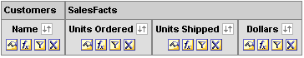
Please note: Delete the Region column from the request after creating the filter.
  - Click Results:
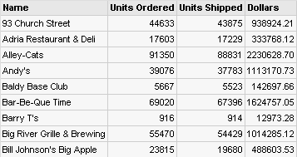
  - Click the Chart button to add a Chart view.
  - Click OK to return to the Compound Layout view.
  - Use the Up Arrow for the Chart view to position the Chart view above the Table view in the Compound Layout view.
  - Verify your work:
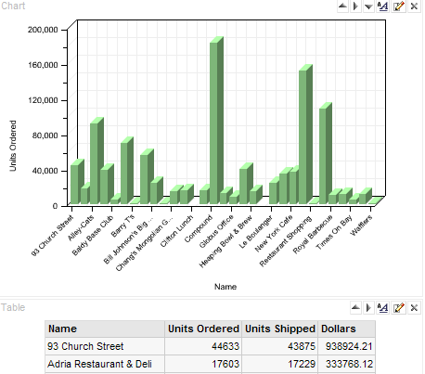
- Create a duplicate of the Chart view. Duplicating a view is useful when you want to make changes to a view while preserving the original view, or when you want to create a new view based on an existing view.
  - Click the Edit View button for the Chart view.
  - Click the Duplicate View button at the top of the workspace.
  - Select Duplicate View from the list.
  - Notice that the duplicate view has the numeral 2 appended to it.
  - Change the chart type to Horizontal Bar.
  - Deselect the check box for the Units Ordered column on the horizontal axis.
  - Select the check box for the Dollars column on the horizontal axis.
  - Click Redraw and check your work.
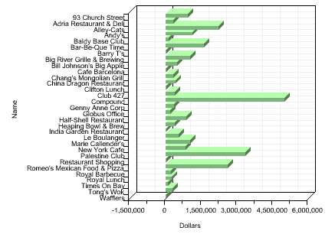
  - Select Compound Layout from the view drop-down list.
  - Select Add View > Chart2.
  - Use the Up Arrow to position the chart2 view above the Table view and below the original Chart view.
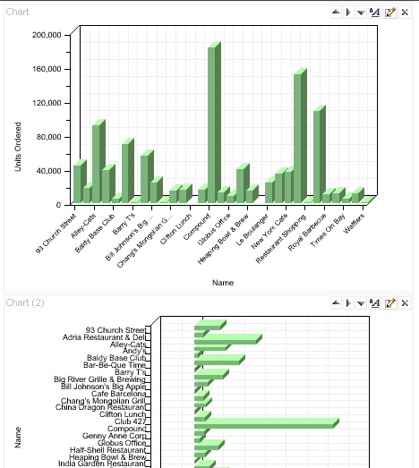
- Add a Column Selector view to the Compound Layout view.
  - Select Add View > Column Selector.
  - In the Column 0 column (Name), select the Include Selector option.
  - Add choices to the column selector by clicking the following columns in the selection pane: Periods.Month, Periods.Year, Customers.Sales Rep, and Customers.State.
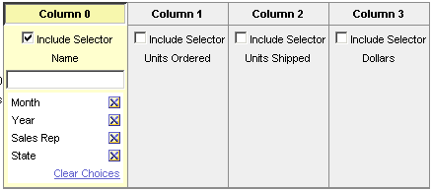
  - Click OK to return to the Compound Layout view.
  - Scroll to the bottom and locate the Column Selector view.
  - Click the Up arrow to move the Column Selector view above the Chart view.
  - Check your work:
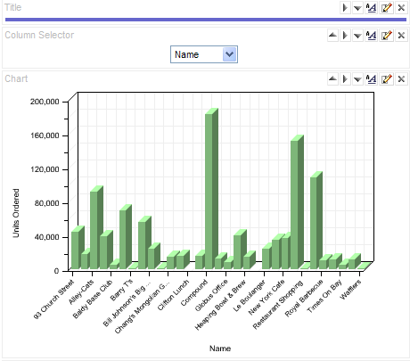
  - Select Month from the Column Selector drop-down list and observe the results:
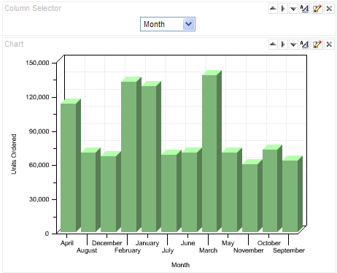
  - Select the other columns from the Column Selector drop-down list and observe the results.
- Add a title to the Compound Layout view.
  - Click the Edit View button for the title view located at the top of the workspace.
  - Select Display Saved Name. When the request is saved, the saved name will appear as the title.
  - Click the Edit button to the right of the Title field.
  - Make your choices for font, cell, and border options, and then click OK.
  - In the Subtitle field, type West Region.
  - Click the Edit button to the right of the Subtitle field.
  - Make your choices for font, cell, and border options, and then click OK. Notice that if Display Results is checked, the results are displayed.
  - In the Logo field, type fmap:Images/report_salesVolume.jpg to display an image in the Title view. This image file is located in C:\SiebelAnalytics\Web\App\Res\s_Siebel77\Images. The folder s_Siebel77 is the default style folder. You learn more about styles in later modules in this course.
  - Click the Edit button to the right of the Logo field.
  - Make your formatting choices, and then click OK.
  - In the Started Time drop-down list, select Display Date and Time to identify when the request started to execute.
  - Click OK to return to the Compound view layout.
  - Save the request as Units Ordered/Shipped – Revenue.
  - Check your work. Your Title view should look similar to the following:
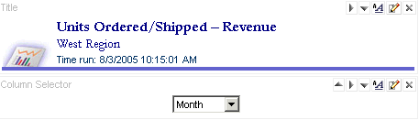
- Preview how the view will appear on an Intelligence Dashboard.
  - Click the Preview button near the top of the workspace. The dashboard preview appears in a new window.
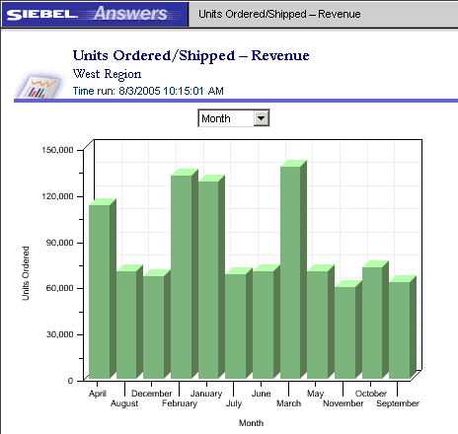
  - Click the Close button to close the preview window.
- Verify that the request was saved and is available in the Web Catalog.
  - Click the Answers link.
  - Verify that the request Units Ordered/Shipped – Revenue is displayed in the selection pane, under My Folder.
  - Click Units Ordered/Shipped – Revenue.
  - Click Modify to return to the Siebel Answers workspace.
- Leave Siebel Answers open for the next lab.
Lab 4-2 Using the Table View
Goals | To use the Table view to show results in a standard table.
Scenario | You use the Table view to display column totals and grand totals, combine values into bins, and specify Table view properties, such as location of paging controls, number of rows per page, green bar styling, and column and table headings.
Time | 15 – 20 minutes
Instructions:
- Create the following request and associated filters:
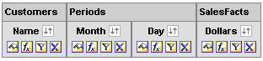
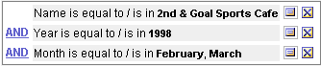
Please note: Delete the Year column from the request after creating the filter.
  - Click Results.
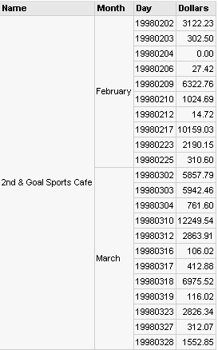
- Specify report totals.
  - Click the Edit View button for the Table view.
  - To add a grand total for the report, click the Grand Total button at the top of the workspace. A grand total is added to the bottom of the table.
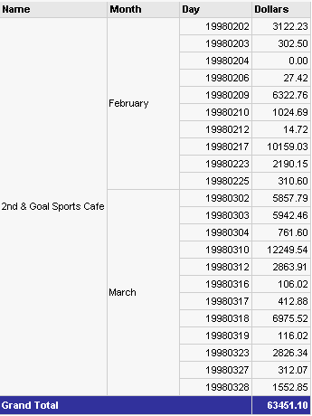
  - Click the Grand Total button again to verify that the option Report-Based Total is selected.
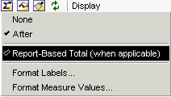
This option is selected by default. If this option is not selected, the Siebel Analytics Server calculates the total based on the entire result set before applying any filters to the measures.
  - Click the Grand Total button again and select the Format Labels option. Specify caption, cell, font, and border options as desired.
  - Click the Grand Total button again and select the Format Measure Values option. Specify cell, font, and border options as desired.
  - Click the Total By button for the Month column to apply totals for the individual column.
  - If desired, click the Total By button for the Month column again to modify the format for labels and measure values.
  - Your request should look similar to the following:
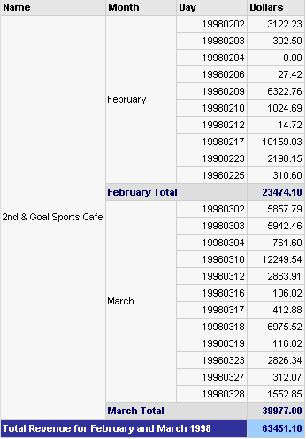
- Combine values into bins.
  - Click the Edit Formula button for the Day column. The Edit Column Formula dialog box opens. Notice the column formula.
  - Click the Bins tab.
  - Click Add Bin. You want to build bins that will compare revenue in the first half of the months with revenue in the second half of the months.
  - In the Create/Edit Filter dialog box, create a filter where Day is between 19980201 and 19980214.
  - Click OK.
  - In the Edit Bin Name field, type February – First Half.
  - Click OK.
  - Add another bin called February – Second Half with a filter where Day is between 19980215 and 19980228.
  - Repeat the steps and create two more bins: March – First Half and March – Second Half.
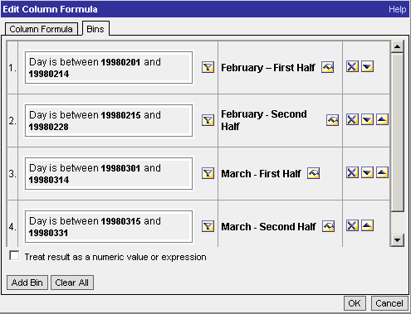
  - Click the Column Formula tab and examine the column formula created when you built the bins.
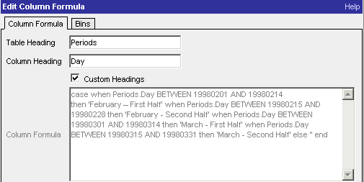
  - Click OK to close the Edit Column Formula dialog box.
  - Your results should look similar to the following:
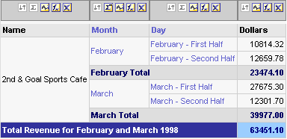
- Specify Table view properties.
  - Click the Edit Formula button for the Day column.
  - Click the Bins tab.
  - Click Clear All.
  - When prompted with the Clear Bins message, click No to revert to the original formula.
  - Click OK to close the Edit Column Formula dialog box. The table reverts to its original format.
  - Click the Criteria tab.
  - Delete the filter Name is equal to / is in 2nd & Goal Sports Café.
  - Add the Region column and a filter where Region is equal to / is in Central.
  - Delete the Region column.
  - Click Results.
  - Click the Table View Properties button near the top of the workspace. The Edit View dialog box opens.
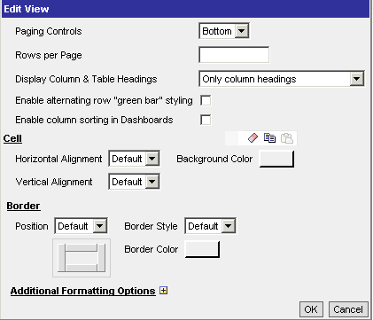
  - Experiment with specifying the Table view properties: paging controls, rows per page, display column and table headings, and green bar styling.
  - When you are done, save the request as My Table View.
- Leave Siebel Answers open for the next lab.
Lab 4-3 Working with Views
Goals | To add a variety of views to results.
Scenario | You add a variety of views to the results of a request to help you look at data in meaningful and intuitive ways. Preparing multiple views of results helps users to identify trends and relationships in data. You create a request and add Filters, Legend, Narrative, Ticker, and Logical SQL views.
Time | 15 – 20 minutes
Instructions:
- Create the following request:
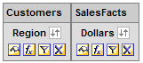
- Click Results.
- Add a Filters view.
  - Select Add Views > Filters to add a Filter view.
  - Use the arrows to move the Filter view above the Table view and below the Title view.
  - Drill down on the Central region.
  - Notice how the Filter view changes after drill down. This is because drilling down limits the result set and automatically creates a filter. The Filter view tracks the results.
  - Drill down on the Gulf sales district.
  - Drill down on Mary Silver.
  - Check your results:
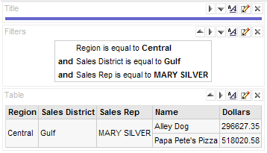
  - Click the Criteria tab. Notice that columns and filters have been automatically added to the original request.
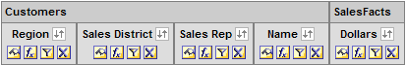
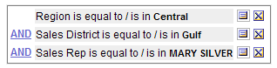
  - Remove all filters
  - Remove the Sales Rep and Name columns.
- Add a Legend view.
  - Create a conditional format for the Dollars column where dollars less than one million is red, dollars between one million and two million is yellow, and dollars greater than two million is green.
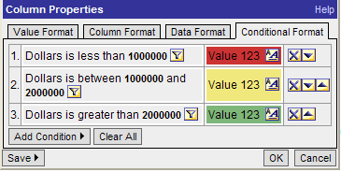
  - Click Results.
  - Delete the Filters view you created in an earlier step.
  - Select Add View > Legend.
  - Set legend items per row to 3.
  - Populate title and items based on the following screenshot. Use the Sample Text format buttons to set colors to match those used in the conditional formatting for the Dollars column.
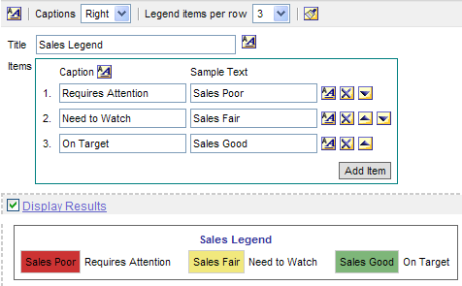
  - Click OK to return to the Compound Layout view.
  - Check your work.
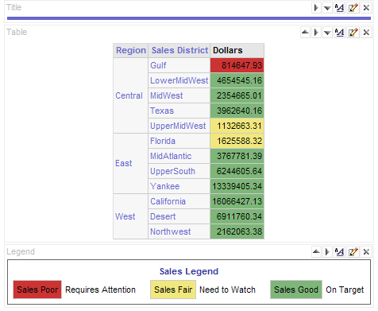
- Add a Narrative view.
  - Select Add View > Narrative.
  - In the Prefix field, type This report shows sales by sales district. The sales districts are:.
  - Select the text in the Prefix field and click the Bold button .
  - Place your cursor at the end of the text, after the bold tag, and click the Line Break button twice.
  - In the Narrative field, type @2. This will include the results from the second column (Sales District) in the narrative text. You use @n to return results from a column, where n represents the desired column based on the sequence of columns in the request. In this example, Sales District is the second column in the request.
  - Place your cursor after @2 and click the Line Break button.
  - In the Postfix field, type Please address sales marked as red.
  - Bold the text in the Postfix field.
  - Place your cursor at the beginning of the text in the Postfix field, before the bold tag, and click the Line Break button once.
  - Check your work.
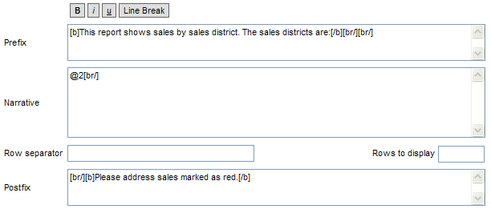
  - Click OK to return to the Compound Layout view and check your results.
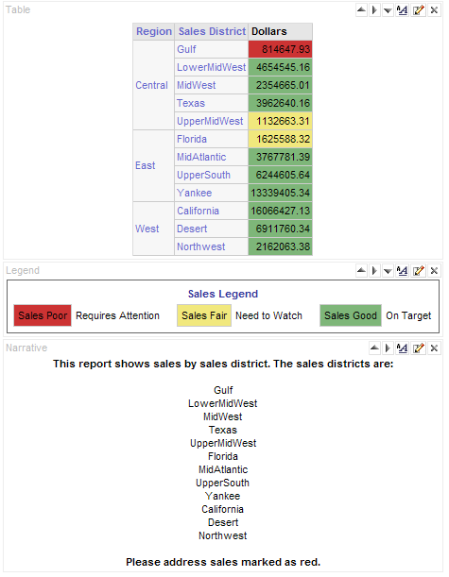
- Add a Ticker view.
  - Select Add View > Ticker.
  - In the Beginning Text field, type Total Sales by Sales District between the <tr> and <td> tags.
  - In the Row Format field, type @2[br/]@3. This will display data from columns two and three in separate rows in the ticker. Column 2 is Sales District and column 3 is Dollars.
  - Check your work.
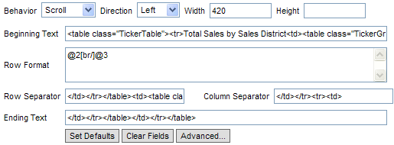
  - Accept all other defaults and click OK to return to Compound Layout view.
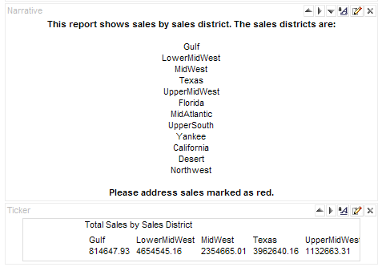
- Add a Logical SQL view. This view is useful for Administrators and developers for debugging purposes, and is usually not included in results for typical users.
  - Select Add View > Logical SQL.
  - Verify that a logical SQL view was added to the Compound Layout and that the logical SQL for the query appears.
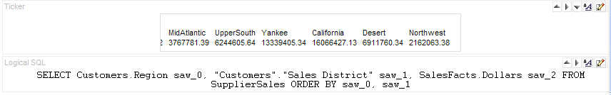
- Save the request as My Views.
- Leave Siebel Answers open for the next lab.

